Four photos (One without West Virginia, one with WV, so placed in timeline back to back it might look like one was drawn in when the speaker reads “West Virginia” Two more are zoomed in ones, one with a logo if that would flow well… Otherwise use the plain white logo when the reader reads “Spruce School of Real Estate”)Looking to get a real estate license in West Virginia?

(Possibly even use this cropped one so it has a zoomed effect for when the word “West Virginia” is said… Really up to you what flows best in your software.)

(Another idea I had was the next photo could have the logo appear when the girl says “Spruce School of Real Estate” OR it could just go to the plain isolated logo attached below. I actually think the plain logo large might be good as it’s not as cluttered but I guess this is all really contingent on how your software utilizes all this.)


[LOGO] (Make note this is a new logo with a much better dpi. Created from an eps file. Please use this logo from now on.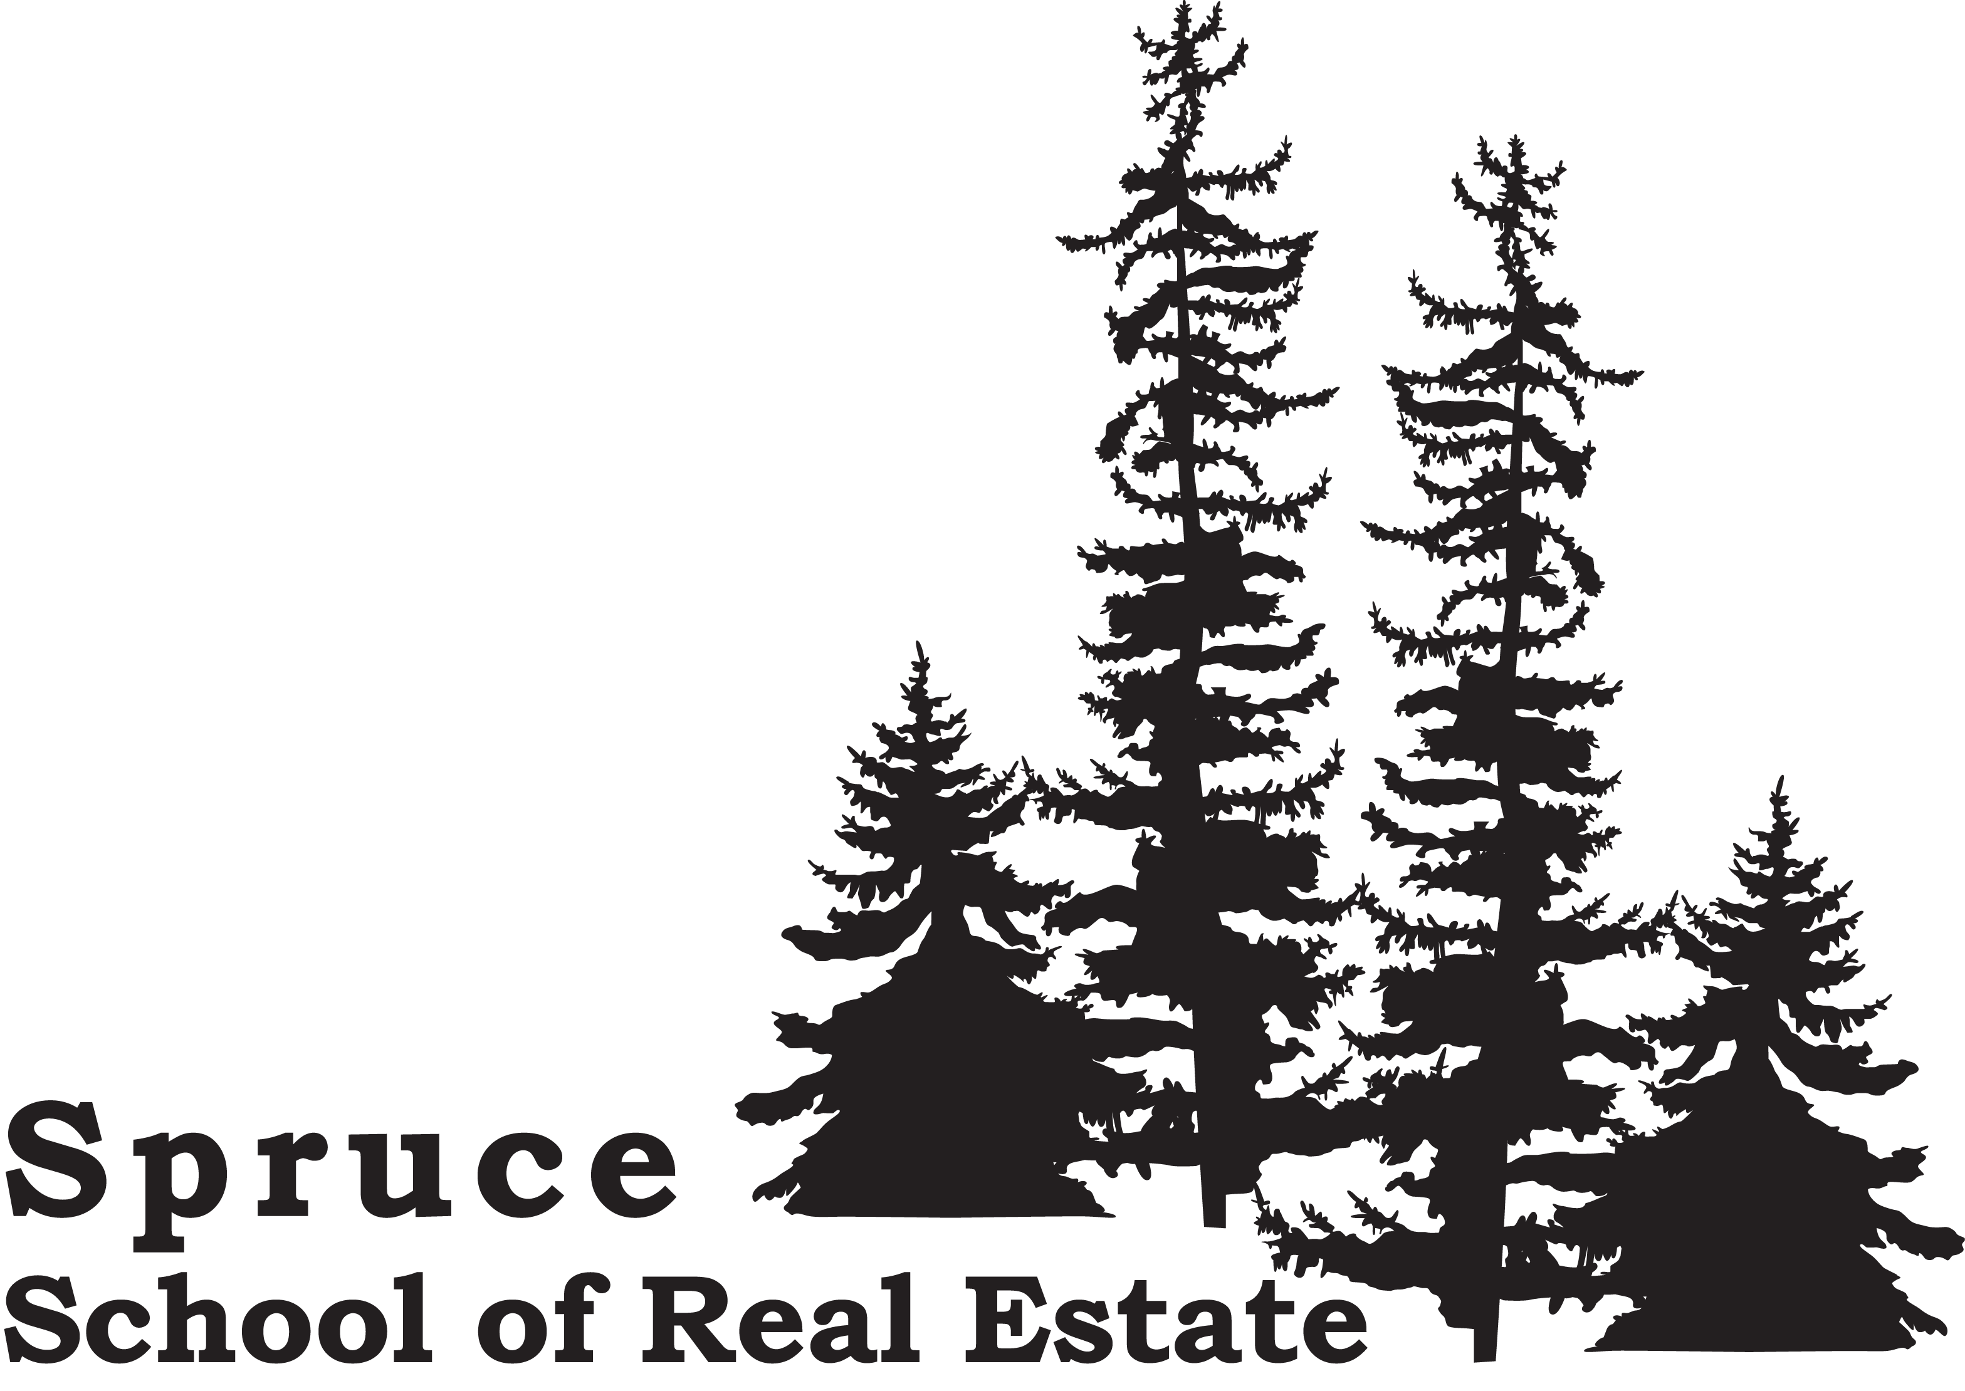 Spruce School of Real Estate.
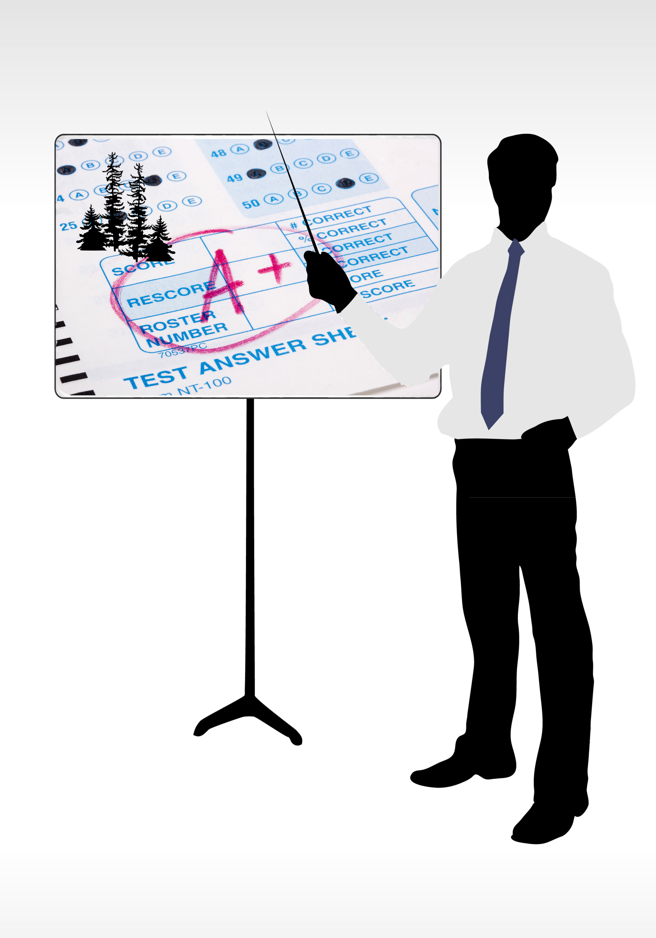
Looking to pass the WV real estate exam? Spruce School of Real Estate.
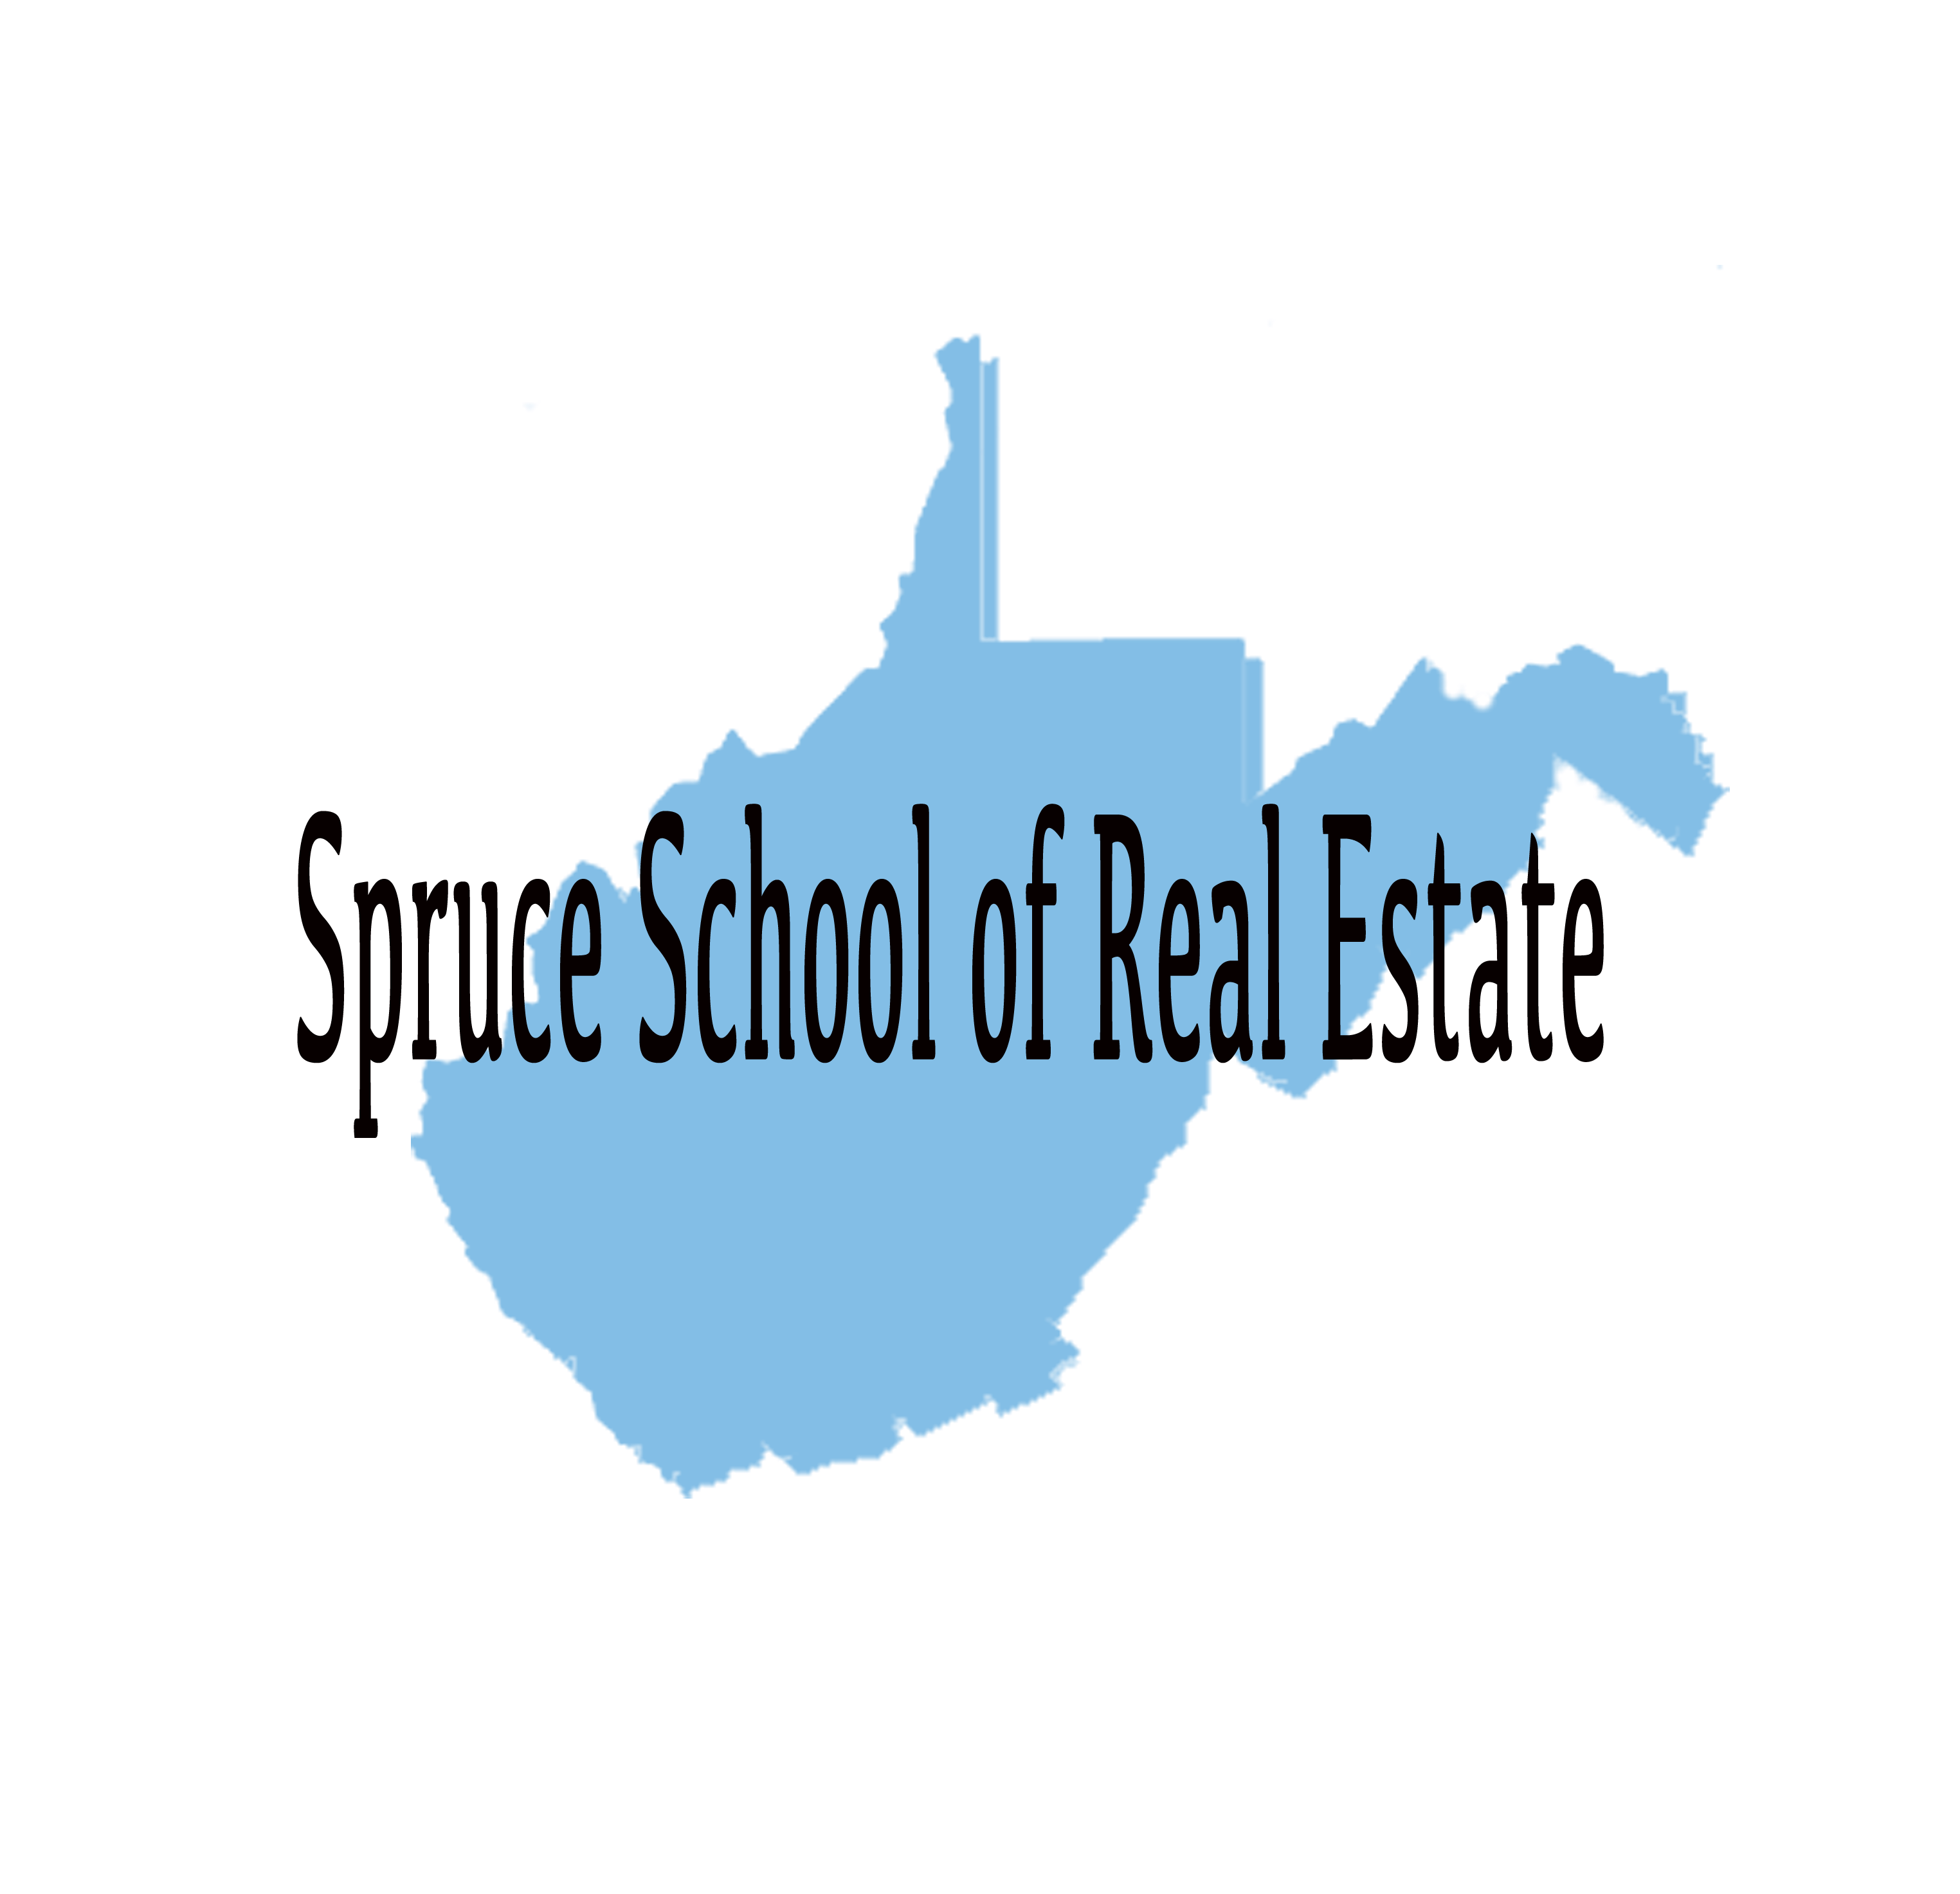

Every month the West Virginia Real Estate Commission publishes which students pass the real estate licensing exam

and guess which school has held the #1 spot for producing  PASSING students month after month for twenty years?

Spruce School of Real Estate.

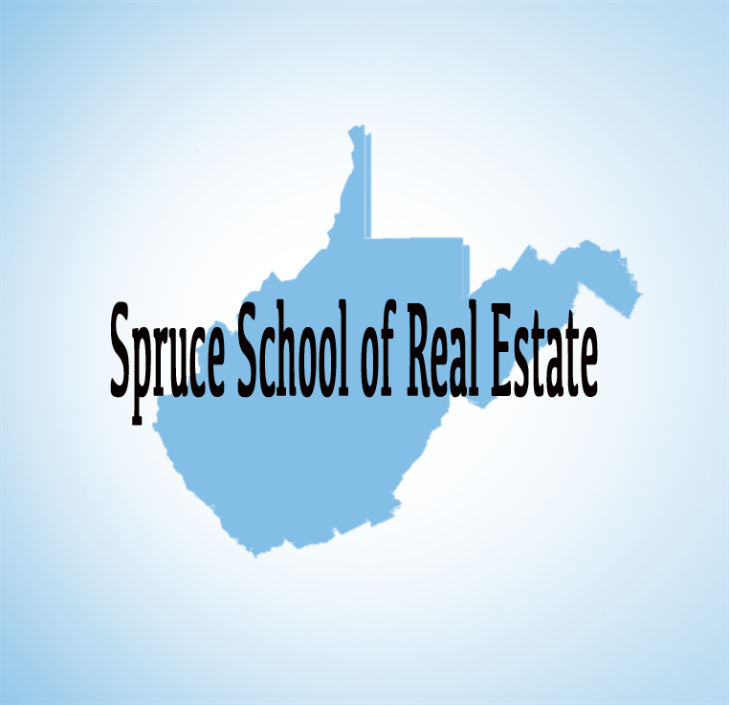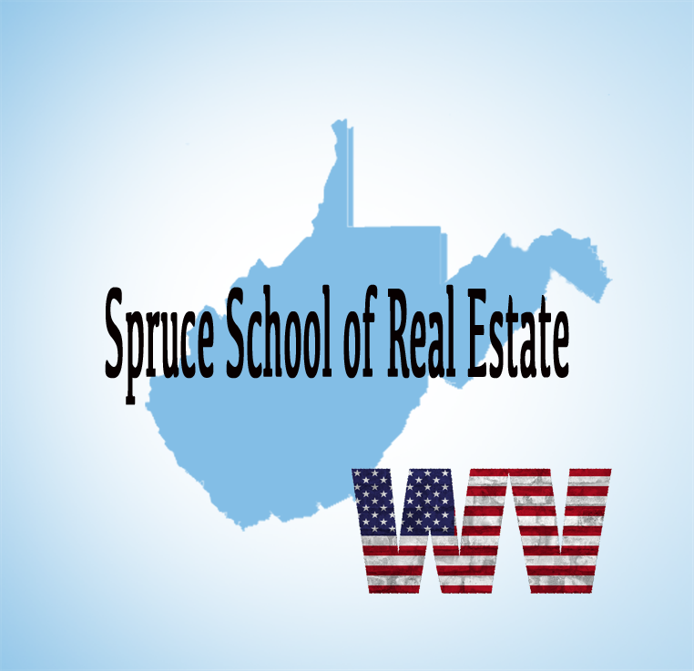
(My thoughts on adding the WV with a translucent background is you can place the images in your timeline back to back making the WV seem like it appears)(file is here just if you want to use WV with transparent background… not necessary to use this image if the above previous image looks nice and plays the role of illustrating when the words “WV” are said… However, if you can make this graphic flow in a timeline better use it as you want)

If you're looking to get your real estate license in WV don't waste

any time going anywhere BUT Spruce School of Real Estate.

Spruce has perfected YOU passing the state exam and Spruce has earned the title of


being the #1 West Virginia Real Estate School because our students pass the test.

(3 images so they can build as the animation moves along? Meaning the hand would write 1-800-864-7318, then the web address… then display both)
Call 1-800-864-7318 or check us out at www.SpruceSchool.com



